**Big Data Analytics and Applications Lab Assignment 11**

**Class Id:** 30  
**Student Id:** 16221783

**Task 1:**

**TensorFlow Programming:**

Write a TensorFlow program for the following Task.   
a.Generate captions for your own dataset that is not covered in class tutorial using the model provided.  
b.Generate 4 captions for each image. (Beam Search k=4)

**Following screenshots display the inputs and their corresponding captions generated by the show and tell model.**

**Image 1**

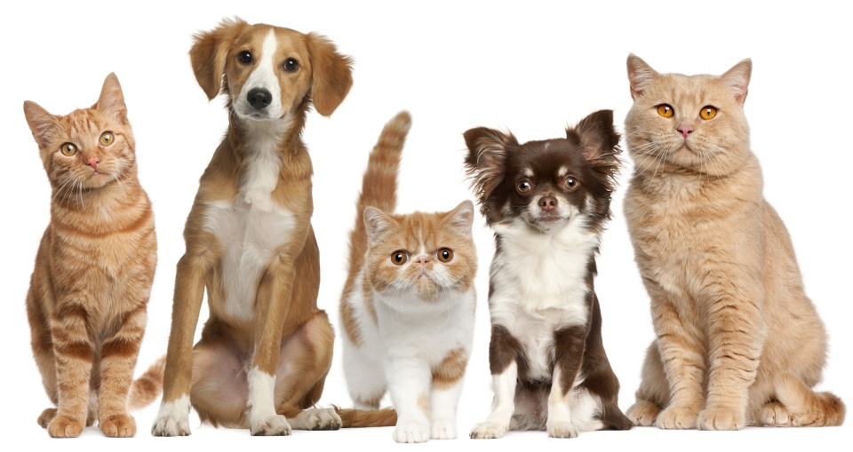

**Captions generated for the above image**

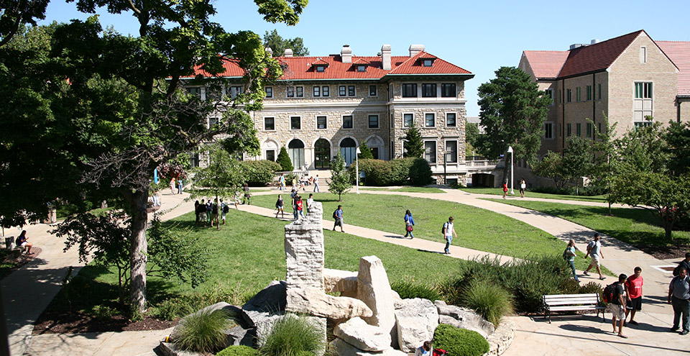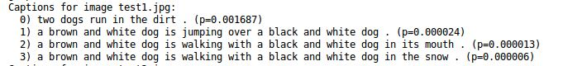

**Image 2**

**Captions generated for the above image**

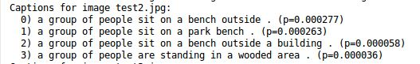

**Image 3**

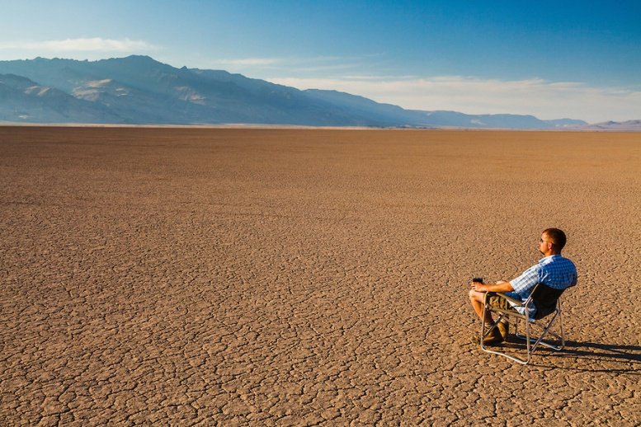

**Captions generated for the given image**

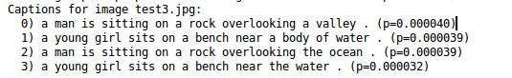

**Overall output for all the three images**

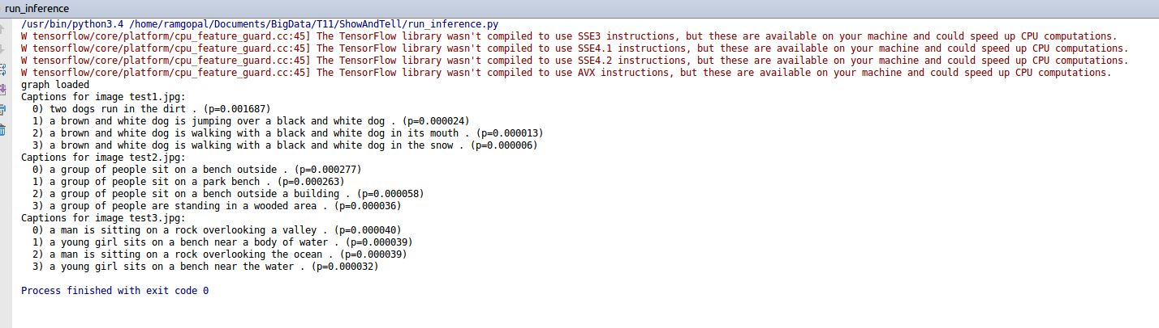

**Task 2:**

**2.Web based Q&A:**

Develop a web based question and answering system similar to that covered in class.   
b.Develop Q & A that is related to your project.

**Installed applications on heroku**

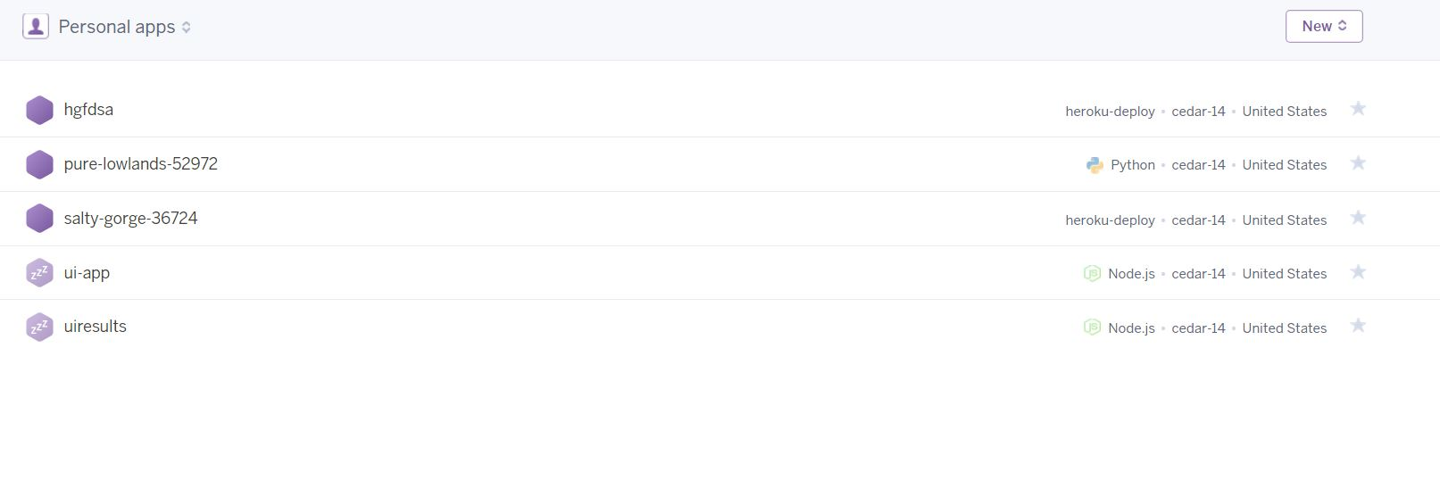

**Results page running on local host**

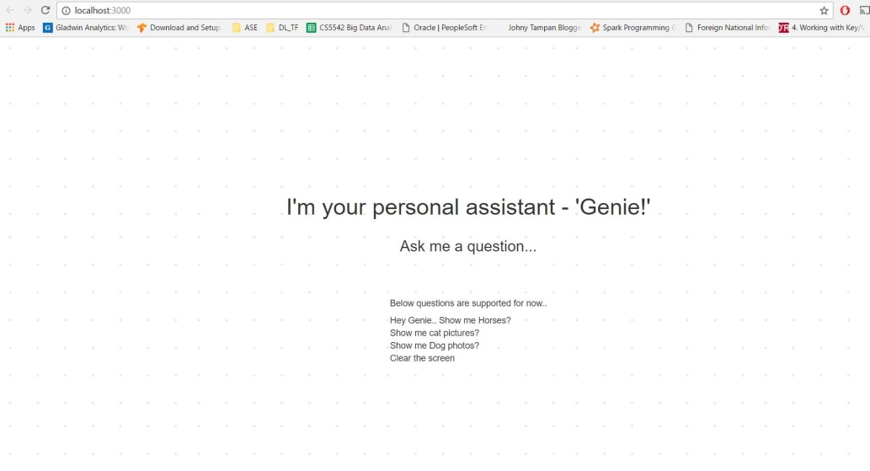

**Web simulator**

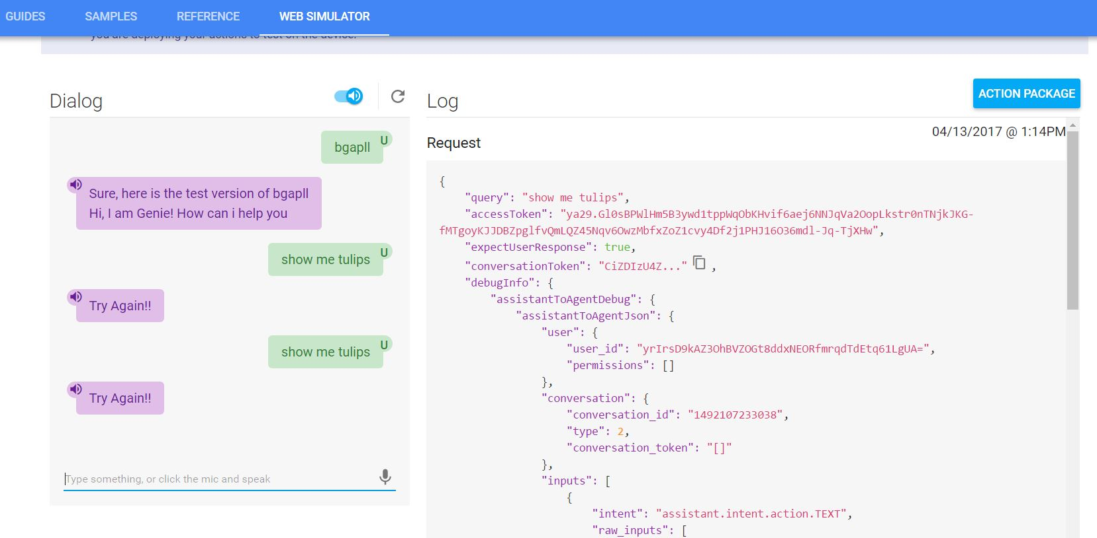

**Tried to implement a Q&A system in tensorflow by using the given code, but I was unable to retrieve results.**